Writing in MLA 7 style: General Guidelines
All guidelines should be moderated by your teacher’s instruction which override any guidelines here.
- Your paper should be double-spaced in Times New Roman 12 pt. font
- Use 1 inch margins all around
- Leave only one space after periods or other punctuation marks (unless otherwise instructed by your instructor).
- Use the Tab key to indent the first line of each paragraph one-half inch from the left margin.
- Create a header to number all pages consecutively in the upper right-hand corner. (Note: Your instructor may ask that you omit the number on your first page. Always follow your instructor's guidelines.)
- Italicize titles of longer works, such a books, magazines/journals, and websites. Use italics to provide emphasis only when absolutely necessary.

Formatting the First Page of Your Paper
- Do not make a title page for your paper unless specifically requested (always follow your instructor’s guidelines).
- In the upper left-hand corner of the first page, list your name, your instructor's name, the course, and the date. This first page heading should also be double-spaced.
- Double space again and center the title. Do not underline, italicize, or place your title in quotation marks; do not use all capital letters. Use standard capitalization for titles.
- Use quotation marks and/or italics when referring to other works in your title, just as you would in your text: Fear and Loathing in Las Vegas as Morality Play; Human Weariness in "After Apple Picking"
- Double space between the title and the first line of the text.
- Create a header in the upper right-hand corner that includes your last name, followed by a space with a page number; number all pages consecutively with Arabic numerals (1, 2, 3, 4, etc.), one-half inch from the top and flush with the right margin. (Note: Your instructor or other readers may ask that you omit last name/page number header on your first page. Always follow instructor guidelines.)
See sample MLA style first page on reverse of this paper:

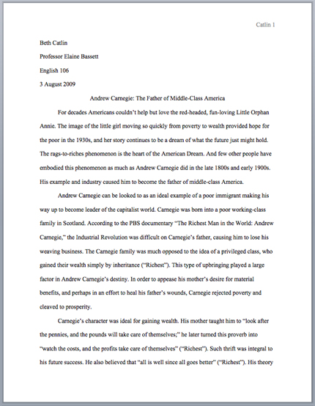
The First Page of an MLA Paper

The preceding guidelines were excerpted from the MLA 2009 Formatting and Style Guide from the Online Writing Lab (OWL) at Purdue University. The sample first page is taken from the site.

For further instruction visit the OWL at http://owl.english.purdue.edu/owl/resource/747/01/

Quoting Plays in Text MLA Style
When quoting dialogue from a play in the text of your paper, it should be set off from the rest of your text.
- Begin each part of the dialogue with the appropriate characters name typed in all capital letters and indented one inch from the left margin.
- Follow the name with a period, then begin the quotation.
- Indent all following lines of that character’s speech by an additional one quarter inch.
- When the dialogue switches to another character, start a new line indented one inch from the left margin and continue as before
- Stage directions are treated like other quoted text. If they interrupt the grammatical sense of your sentence, they may be replaced with an ellipse, that is three periods with a space before each one and a space after the last one (. . . ).
- In creating parenthetical citations for commonly studied verse plays and poems, omit page numbers and cite by a division such as act, scene, canto, book, part, or line, with periods separating the various parts.
- In general, use arabic numerals rather than roman numerals for division and page numbers.
  - If, however you are citing page numbers from a preface or or another section of a book that is numbered with roman numerals, use roman numerals
  - Always use arabic numerals for volumes, parts, books and chapters even if the original source does not
  - You may use roman numerals for acts and scenes in plays if your teacher instructs you to do so
- A parenthetical reference for a quotation that is set off from the text follows the last line of the quotation. In this case, no punctuation follows the parenthetical citation.
The following examples are taken from the MLA Handbook for Writers of Research Papers, 7th edition.
Marguerite Dura’s screenplay for Hiroshima mon amour suggests at the outset the profound difference between observation and experience:
HE. You saw nothing in Hiroshima. Nothing.
SHE. I saw everything. Everything. . . .The hospital, for instance, I saw it. I’m sure I did. There is a hospital in Hiroshima. How could I help seeing it?
HE. You did not see the hospital in Hiroshima. You saw nothing in Hiroshima. (2505-06)
A short time later Lear loses the final symbol of his former power, the soldiers who make up his train:
GONERIL. Hear me, my lord.
What need you five-and-twenty, ten or five,
To follow in a house where twice so many
Have a command to tend you?
REGAN. What need one?
LEAR. O, reason not the need! (2.4.254-58)

